|  |
| --- |
| PS2Win |
| Weekly Report |
| Keep Your Time |

|  |
| --- |
| Filipe Brandão  18-05-2013 |

**Team Members:**

Carla Machado

David João

Filipe Brandão

João Girão

João Martins

Mário Oliveira

Rui Ganhoto

**Week 13**, 13th of April to 20th of May

Content

1. Week Activities 1

1.1. Work Executed 1

1.2. Work Analyses 1

1.3. Achievements 1

2. Impediments 1

3. Plans For Next Week 2

4. Progress 2

4.1. Earned value and/or Gantt Image 2

4.2. Effort by task 3

4.3. Individual effort 3

5. Individual log 4

**Images**

Figure 1: Earned Value 2

Figure 2: Week effort by task type 3

Figure 3: Week effort by team member 3

**Tables**

Table 1: List of Contributors ii

Table 2: Version history ii

Table 3: Log of individual effort 4

|  |  |  |  |
| --- | --- | --- | --- |
| **Authors and Contributors** | | | |
| **Date** | **Name** | **Contacts** | **Contribution** |
| 18-05-2013 | Filipe Brandão | a21180276@alunos.isec.pt | Author |
| 20-05-2013 | Mário Oliveira | a21170292@alunos.isec.pt | Contributor |
| 20-05-2013 | Carla Machado | a21170460@alunos.isec.pt | Contributor |
| 20-05-2013 | Rui Ganhoto | a21170460@alunos.isec.pt | Contributor |
|  |  |  |  |
|  |  |  |  |

Table 1: List of Contributors

|  |  |  |  |  |  |
| --- | --- | --- | --- | --- | --- |
| **Revision History** | | | | | |
| **Date** | **Description** | **Author** | **Version** | **Approvers** | **State** |
| 18-05-2013 | Creation of first draft | Filipe Brandão | 0.1 |  | Draft |
| 20-05-2013 | Adding content | Filipe Brandão | 0.2 |  | Draft |
| 20-05-2013 | Changing State | Filipe Brandão | 0.2 |  | Ready for Revision |
| 20-05-2013 | Document reviewed | Mário Oliveira | 0.2 |  | Ready for Revision |
| 20-05-2013 | Minor corrections and changing state | Filipe Brandão | 0.3 |  | Ready for Approval |
| 20-05-2013 | Some comments, and change suggestions. Approved |  | 0.2 | Carla Machado | Ready for Approval |
| 20-05-2013 | Minor Corrections | Filipe Brandão | 0.4 |  | Ready for Approval |
| 20-05-2013 | Approved |  | 0.4 | Rui Ganhoto | Ready for Approval |
| 21-05-2013 | Versions corrected. Baselined | Filipe Brandão | 1.0 |  | Baselined |
|  |  |  |  |  |  |

Table 2: Version history

# Week Activities

# Work Executed

* Finished Test Plan (is now ready for revision)
* Finished Database Module
* Started “Delete and Edit tasks” functionality and UI development
* Started “Export app data” functionality and UI development
* Started “Task Details” functionality and UI development
* Started “Task listing” functionality and UI development
* Preparation for Code Inspection
* Started reviewing the Test Plan
* Updated Project Planning Process and Software Development Plan

# Work Analyses

Unlike the two past weeks, this week we decided to meet and work together (like we were doing before). Although the work for this week was mainly individual, we think that working together gives us a better idea of the progress. This way, coding doubts were solved immediately with the help of the member who had more knowledge about the framework.

The team seemed more motivated now that we started coding and all the work done is getting visible.

Although the UI development was allocated to Rui Ganhoto and David Silva, by request, it was given freedom to choose if each team member developed the UI related to the task allocated to him.

# Achievements

* Test plan is ready for revision
* Database Module is ready for the code inspection
* Project Planning Process and Software Development Plan is updated

# Impediments

Team members allocated to the Test plan reported that their lack of knowledge about the tool Enterprise Architect compromised their performance. Also, during the coding tasks, the lack of knowledge about the framework led to time being spent researching and experimenting.

# Plans For Next Week

* Finish the Code Inspection
* Finish all the coding tasks already started
* Start “Settings”, “Shortcuts” and “Inactivity detection” coding

# Progress

# Earned value and/or Gantt Image

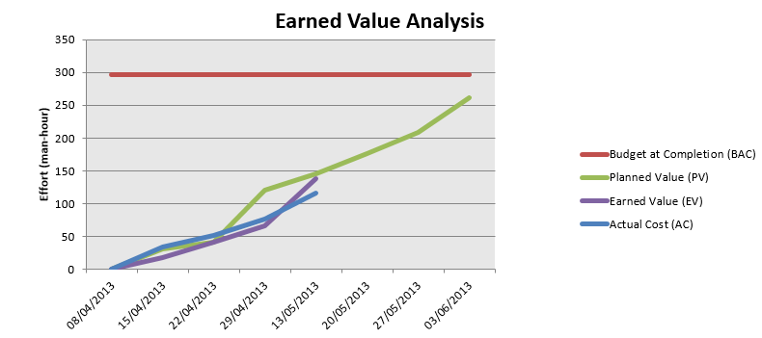

Figure 1: Earned Value

Planned Value = 177h

Earned Value = 175h

Actual Cost = 151h

# Effort by task

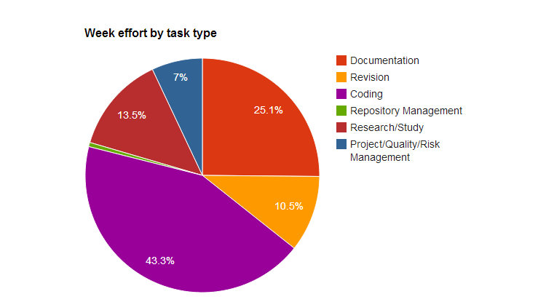

Figure 2: Week effort by task type

# Individual effort

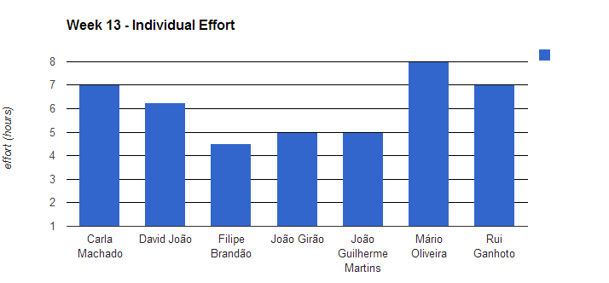

Figure 3: Week effort by team member

|  |  |
| --- | --- |
| **Name** | **Effort(hours)** |
| Carla Machado | 7 |
| David João | 6.25 |
| Filipe Brandão | 4.5 |
| João Girão | 5 |
| João Guilherme Martins | 5 |
| Mário Oliveira | 8 |
| Rui Ganhoto | 7 |

Table 3: Log of individual effort

# Individual log

**Carla Machado - Tasks done:**

* Approval of Weekly report week 10 0.25h
* Meeting minute review 0.25h
* Coding EditTask interface and creating the resource file 1h
* Research about WPF objects and implementation 0.5h
* Continuation of the implementation of the functionality Edit Task 2.5h
* Research about WPF objects and implementation 1h
* Verification of the status of the open unconformities 0.25h
* Preparation of the coding inspection 1.25

**David João - Tasks done:**

* Linking tests to requirements 1.25h
* Finishing test plan and documentation generation 2.75h
* Inactivity window creation 0.5h
* Tiny correction to Inactivity window 0.25h
* Another tiny correction to test plan generated document 0.25h
* Agenda 0.5h
* Preparation of the coding inspection 0.75h

**Filipe Brandão - Tasks done:**

* Fix EV 0.5h
* Analyse estimation differences 0.5h
* Weekly Report draft 0.25h
* Update dashboard 0.25h
* Update Project Planning Process and SDP 0.5h
* Research about "milestones" 0.5h
* Preparation for Code Inspection 1h
* Starting CSV Export 0.75h
* Finishing Weekly Report 0.25h

**João Girão - Tasks done:**

* Changing State of the SRS Document and discussion with the moderator 0.5h
* Task Details UI, Functionality and Integration + WPF Research 3.25h
* Task Details UI, Functionality and Integration + WPF Research 1.25h

**João Martins – Tasks done:**

* Minutes 0.75h
* Linking tests to requirements 1.75h
* Finishing test plan 2.5h

**Mário Oliveira - Tasks done:**

* Update repository 0.25h
* Revision weekly report - Week 9 0.5h
* Show task listing UI 1h
* Show task listing functionality 1.25h
* WPF Research 2.75h
* Revision of Project Planning Process and SDP 0.25h
* Revision of Test Plan 1h
* Preparation of the coding inspection 1h

**Rui Ganhoto - Tasks done:**

* Database Connectors Development 2.5h
* Interface Create Task and Task List Development 1.25h
* Database Unit Tests 0.5h
* Main Window Interface Creation (Message window) 1.5h
* Task List Interface Development 1h
* Weekly Report 10 Approval and Risk Assessment 0.25h